**Part 2: Hosting a Static Portfolio Website on S3**

**Steps:**

1. **Created new S3 bucket.**
2. **Upload the html file**
3. **Enabled the Static website hosting in properties**
4. **Go to permission and write and save bucket policy.**
5. **Now open html file info**
6. 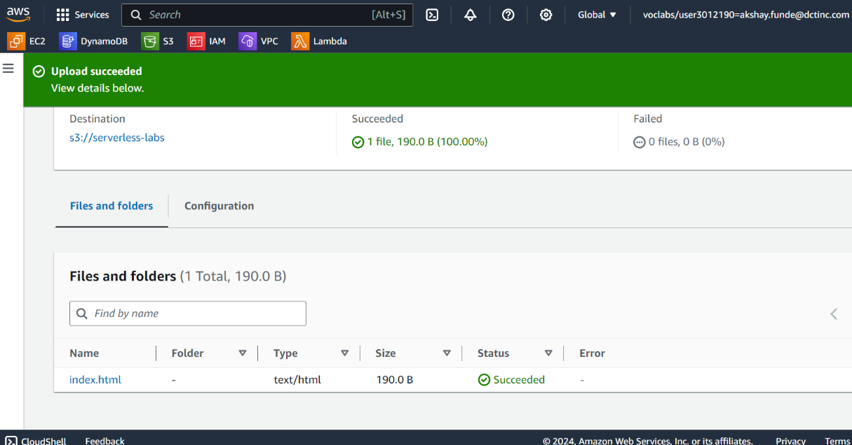**Go to object url now you can see my webpage**



